Prof. Julio C. Durand
Resume

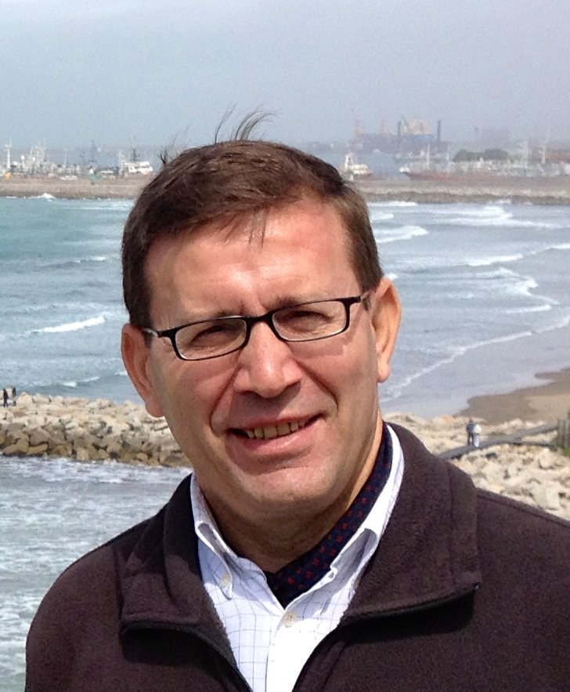

Julio Durand is Professor and former Dean of the School of Education at Universidad Austral. He is responsible for the Office of University Strategic Planning and the Institutional Reputation Unit (URI). He is Director and Professor of Strategic Planning of Universities in the Doctoral Program in Higher Education (UAI-AUSTRAL-UNRN) and Coordinator of the Network of Higher Education Studies (REES).
He was Academic Secretary of the University (2015-2023) and served as a member of the Rector's cabinet. He founded and directed the Master's Program in Management of Educational Institutions (2011-2021). He served as Director of International Relations from 1997 to 2011 and as Secretary General of the University from 2011 to 2014. In 2019 he led the accreditation of the institutional distance education system (SIED) of Universidad Austral.
He is a Public Accountant from the Pontificia Universidad Católica Argentina, and a Doctor of Philosophy – Education section – graduated from the University of Navarra, Spain. He has specialized in management of Higher Education Institutions.
In addition to his work as a senior manager, he has carried out advisory activities at other universities (Juan Agustín Maza University, CEMA University, University of Mendoza, National University of Los Comechingones, UNICABA). He has served as an evaluator of new and current HEIs in Argentina and of postgraduate programs at CONEAU, the National Accreditation Office of Argentina; at CACES, the accreditation agency of Ecuador, he participated as an international evaluator in the 2019-2020 fiscal year; as an evaluator of PICT projects of the FONCyT at the ANPCyT, the National Science Agency of Argentina; as a member of the Committees for the Evaluation and Academic Promotion of Professors of the IAE Business School and the Faculty of Business Sciences (Rosario, FCE); as a member of the Jury in the III and XII Internal Competition of research projects, etc.
As a researcher, he is in charge of projects on eXplanable AI and prediction of dropout, ethics and leadership, collegiality, university governance and senior management teams. In educational policy he has studied the conflict with teachers' unions and the loss of classes, and the perception of sex education by students and teachers. He is currently in the Project that studies the impact of the pedagogy of alternation (AIMFR- F. Ondyla) and is a researcher at CeLAPES (Latin American Center for Research in Higher Education of UFRJ). In the past he studied cooperative education at the university; the improvement of quality and academic information in the framework of institutional research, etc. He coordinated the project 'Success and retention of students in higher education'. He was the Argentine coordinator of the C-PRO project to increase the employability of postgraduate students, with the financial support of Europeaid, ALFA III Program. He has conducted research on the academic profession in Argentina, for which he received a postdoctoral research fellowship from the Fulbright Commission. This allowed him to spend three months in 2000 at the Center for International Higher Education at Boston College, whose director was Professor Philip G. Altbach.
Full CV: https://www.austral.edu.ar/investigadores/durand-julio/

9-IX-2026

