Prof. Julio C. Durand
Resume

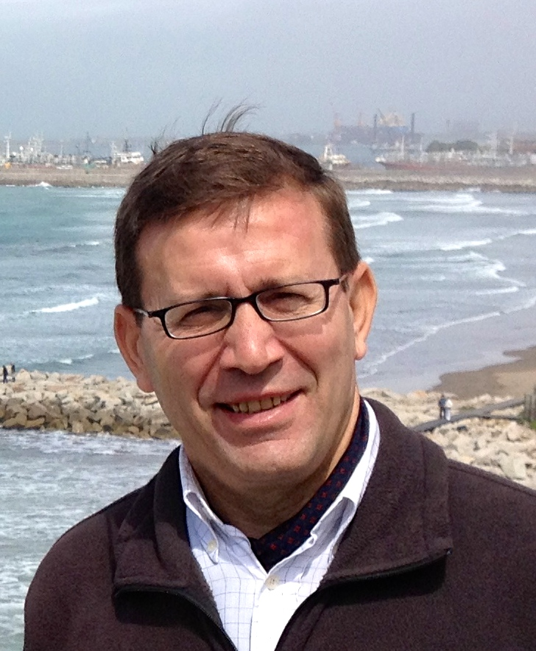

Julio Durand is a Full Professor and former Dean of the School of Education of Universidad Austral. He is the responsible of the University Strategic Planning Office and Institutional Reputation Unit (URI). He is the Director and Professor of Strategic planning of universities in the Doctoral Program in Higher Education (UAI-AUSTRAL-UNRN) and Coordinator of the Higher Education Studies Network (REES).
He was the University Academic Registrar (2015-2023) and served as a member of the Rector cabinet. He founded and directed the Master Program in Management of Educational Institutions (2011-2021). He served as Director of International Relations from 1997 to 2011 and as the Registrar of the University from 2011 to 2014. In 2019 he lead the accreditation of the institutional distance learning system (SIED) of the Universidad Austral.
Dr. Durand is in charge of the Research Center of Educational Policy and Higher Education. He is the academic advisor of the Regional Coordination Office for Latin American and the Caribbean in the GLOBE Program (NASA) and responsible of Linkyou Project, Erasmus Mundus Program 2017-2019.
He is a Certified Public Accountant from Pontificia Universidad Católica Argentina, and Doctor in Philosophy – Education section- graduated from Universidad de Navarra, Spain. He has specialized in management of Higher Education Institutions.
Besides his work as a top administrator, he has performed advisory activities and assessment in other universities (Universidad Juan Agustín Maza, Universidad CEMA, Universidad de Mendoza, Universidad Nacional de los Comechingones, UNICABA). He has served as a peer evaluator of new and current HEI in Argentina and of postgraduate programs in CONEAU, Argentina’s National Accreditation Office; in CACES, Ecuador’s accreditation agency, he participated as international evaluator in the 2019-2020 exercise; as PICT projects evaluator of the FONCyT in the ANPCyT, Argentina’s National Science Agency; as a member of the Committees for the evaluation and academic promotion of professors of IAE Business School and the School of Management Sciences (Rosario, FCE); as member of the Jury at the III and XII Internal Contest of research projects, etc.
As a researcher, he is in charge of projects on ethics and leadership, collegiality, university governance and top management teams; in educational policy he is studying the conflict with teachers unions and the loss of classes, and the perception of sexual education by students and teachers. He is currently in the Project studying the impact of alternation pedagogy (AIMFR- F. Ondyla) and researcher of the CeLAPES (Centro Latinamericano de Pesquisa en Ensino Superior de UFRJ). In the past he studied cooperative education in the university; the improvement of quality and academic information as part of institutional research, etc. He coordinated the project ‘Student success and retention in higher education’. He was the Argentinean coordinator of the C-PRO project to increase the employability of graduate students, with the financial support of Europeaid, ALFA III Program. He has conducted research into the academic profession in Argentina, for which he was awarded a research postdoctoral grant by the Fulbright Commission. This allowed him to spend three months in 2000 in the Center for International Higher Education at Boston College, whose Director was Professor Philip G. Altbach.

12-III-2024
Research activities and publications
R+D+i Projects
Higher Education Policies in Latin America: Expansion, Diversification, Institutional Models, and Elite Renewal. Argentina and its paradoxes. IR: Julio Durand. Team: M. Ligia Barboza and A. Pires. 19th UA Internal Competition, 2024-2025. CPCS Resolution No. 80/23 Amount: ARS 800,000.-
Measuring the relationship between institutional diversity and student equity in Latin American countries. Director: María Ligia de Oliveira Barboza. CNPQ accredited. Federal University of Rio de Janeiro (and others). Laboratory of Research in Higher Education (LAPES). 2023-2024
ESD and Educational Social Responsibility: Training of school leaders as a strategy for SDG4. Team: Carlos Pujadas and Sebastián Lagutto (UTN). HUC Matchmaking Research Partnerships Fellow. 2022
Impacts of Family Educational Centers for Alternance Training (CEFFA): Perceptions of Actors in Different Countries. Argentina (2022). International and local phase. 17th Universidad Austral Internal Research Competition, 2022-2023. Principal Investigator. CPCS Resolution No. 80/21. Financing: $ 180.000.-
This is a descriptive study of the perception of students and teachers about the current debates on comprehensive sexuality education. 15th Universidad Austral Internal Research Competition, 2019-2021. Principal Investigator. CPCS Resolution No. 102/19. Financing: $ 115.000.-
The Teachers' Conflict: Federal Fragmentation and Impact on the Loss of School Days. 2017-2019
Children's institutions in Argentina during the last century. Paradigm shifts, and role in the socialization process of children at social risk. PhD thesis by Patricia Rodríguez Aguirre, UCA.
Project Linkyou. Erasmus +. Funded by the European Union with € 92,534.- Execution 2017-2019.
"Education, Science and Environment". Latin American Regional Office, GLOBE Program, NASA, 2015-2017: USD 92,115.- // 2017-2019: USD 92,754.- // 2019-2023: USD 530,000.-
The impact of global rankings on Latin American Higher Education. The case of Argentina and Chile. Principal Investigator. Fellow: Mag. María Pita. VIII Internal Competition. 2013. Allocated funds: $15,800.-

Conferences & Speechs
Durand Mazza, J. C., Gagnon C., et al. (org.) (2023). Symposium: The Pedagogy of Alternation. Particularity and impact of CEFFAs from the point of view of the aims and means. Cases from different countries and future perspectives. In X IBERO-AMERICAN CONGRESS OF PEDAGOGY – Pedagogy at ground level: education, diversity and social justice, Mexico City, 21-25/8/2023.
“The University as a community: collegiality in governance and ethics of civic responsibility”. Curitiba, Brasil, 12/4/2023. PUCPR-Globethics Joint Seminar: Ethics in Higher Education for Better Lives and Societies: Governance, Cyber Ethics and Sustainability.
“Developing Sustainable Societies through Higher Education”, Conference, Buenos Aires, 26 - 27 May, 2022. Globethics.net (LAC Regional Office & DESU).
“Shaping Knowledge Societies through Higher Education”, Conference, webinar, Delhi, 16-17 June, 2022. Globethics.net (India Office & Cebu Tech. C., Phil.)
Conference “Promoting Ethical Societies through Higher Education, Nairobi (Kenya), 7-8 July, 2022. Globethics.net (East Africa Office).
“Aseguramiento de la calidad y mejora continua”. La universidad en la era exponencial. Panel La calidad de los programas: Sonia Araujo, Claudio Suasnábar. IdIHCS, UNLP-CONICET, 8-10/11/21.
“Mirar el presente desde el futuro. Prospectiva y planificación estratégica de la educación superior en un entorno turbulento. II Ciclo de conferencias UNQ-UNICEN. Dilemas de la gestión educativa y emergentes actuales. 4/10/21
“La reeducación de la Educación Superior”. ¿Cómo abordar entornos de aprendizaje desafiantes? ALATA – CARE Perú. 20/05/21
“Globethics.net Online Roundtable”: Recalibrating Educational Leadership for Resilient Education. Experiences in Latin America an ICDE Presidents' Forum 2020 Satellite Engagement Event, 20 November, 2020.
“La universidad y su contribución a un liderazgo ético en la sociedad”. En Seminario Internacional ‘Ética en la Educación Superior, una dimensiñón transversal. Desafíos para América Latina.’ Buenos Aires, UCA-Globethics.net, 21/10/2019.
“La construcción de redes interinstitucionales como vehículo de asociatividad para potenciar las capacidades institucionales”. Ateneo de Rectores 2019. Consejo de Rectores de Universidades Privadas – CRUP. Mar del Plata, Universidad FASTA, 15/10/2019.
“Dirigir es educar: desafíos de los equipos directivos en el siglo XXI”. Clase Magistral, Graduación EEDU, Universidad Austral, 29/06/2019.

Publications
Vargas, E. G., Chiappe, A., & Durand, J. C. (accepted). Reshaping education in the era of artificial intelligence: insights from Situated Learning related literatura. Journal of Social Studies Education Research, Vol. 15 (jsser.org)
Durand, J. C., Pujadas, C. y Lagutto, S. (2023). “Educational Social Responsibility in the practice: new pathways in Argentina’s training of principals”. Amélé Adamavi-Aho Ekué, Divya Singh, and Jane Usher (Eds.) Leading Ethical Leaders: Higher Education, Business Schools and the Sustainable Development Goals. Geneve: Globethics. Pp: 45-98. DOI: 10.58863/20.500. 12424/4278463
Sánchez-Agostini, C., Coronado, R., Cannata, J.P., Durand, J. (2021) “Estado regulativo de la Educación Sexual en Sudamérica”. En Aznar Díaz, I., Rodríguez Jiménez, C., Ramos Navas-Parejo, M., Gomez García, G. (Ed.), Desafíos de la Investigación y la innovación educativa ante la sociedad inclusiva (996-1010), Junta de Andalucía-Unión Europea. Dykinson. ISBN: 978-84-1122-024-8.
Durand, J. C. (2020). Argentina: The University contribution to Society’s Ethical Leadership en Deivit Montealegre y María Eugenia Barroso (Eds.), Ethics in Higher Education, a Transversal Dimension: Challenges for Latin America. Ética en educación superior, una dimensión transversal: Desafíos para América Latina. Geneva: Globethics.net, 2020
Durand, J. C. (2019). Equipos directivos cognitivamente complejos en el gobierno colegial de la universidad. En Vicente Castro, F. y Padilla Góngora, D. (Eds.). Del mérito al prestigio. Capítulo 6: págs. 85-96. Badajoz: Crecimiento Humano/INFAD. ISBN: 978-84-121187-0-4
Daura, F. T. y Durand, J. C. (2019). What role do I play in my learning? A study on the academic engagement of higher-education students. New Studies and Research in Education, March 2019: 132-146. Roma: EUSER.
Durand, Julio C. (2019). Prólogo. La educación afectiva y emocional: el desafío de una formación ciudadana sólida. Actas de las IX Jornadas Académicas de Educación. Pilar, 15/06/2018.
Durand, Julio C., Daura, Florencia T., Sánchez Agostini, María Carolina (Directores) y Urrutia, María Susana y Florencia Nizzoli (Coordinadoras) (2019). La educación afectiva y emocional: el desafío de una formación ciudadana sólida. Actas de las IX Jornadas Académicas de Educación. Buenos Aires, Teseopress.
Pita Carranza, María B. y Durand, Julio C. (2018). Llevando un poco de luz a las cavernas universitarias… Debate Universitario, Vol. 6 Nº 12, Junio 2018: 23-40.
Daura, F. T. y Durand, J. C. (2018). What role do I play in my learning? A study on the academic engagement of higher-education students. European Journal of Education, [S.I.], vol.1, n.3, September-December: 53-67. http://journals.euser.org/files/articles/ejed_v1_i3_18/Daura.pdf DOI: http://dx.doi.org/10.26417/ejed.v1i3.p53-67
Durand, Julio C. (2018). Informe sobre el conflicto docente. Paros y paritarias 2018. Diciembre. Año II, 12.18, 85 págs. http://www.austral.edu.ar/eedu/wp-content/uploads/2019/01/Conflicto-docente-2018_12.pdf
Conference Papers
Durand, J. C. & Santos Sharpe, A. (2023). La educación superior en Argentina. Seminario Measuring the relationship between institutional diversity and student equity in Latin American countries. IFCS-UFRJ, Rio de Janeiro, 28/11/2023.
Santos Sharpe, A. & Durand, J. C. (2023). La función de la investigación en la educación superior argentina. Las políticas científicas y el rol de los organismos autónomos. Seminário Políticas de Educação Superior na América Latina: Expansão, Diferenciação e Equidade, UFF-CeLAPES, Niterói, 30/11/2023.
Divinsky, P. & Durand, J. C. (2023). Análisis de las trayectorias de los egresados de los CEFFA en Argentina. En Simposio sobre Pedagogía de la Alternancia, X CONGRESO IBEROAMERICANO DE PEDAGOGÍA – Pedagogía a ras de tierra: educación, diversidad y justicia social, Ciudad de México, 21-25/8/2023.
Durand, J. C. (2023). Argentina’s Higher Education System (first sketch and findings). Unequal Expansion of Higher Education Systems and the Institutional Models in Latin America. SRHE & LAPES, 20/06/2023.
Durand, J. C. (2023). “The University as a community: collegiality in governance and ethics of civic responsibility”. Curitiba, Brasil, 12/4/2023. PUCPR-Globethics Joint Seminar: Ethics in Higher Education for Better Lives and Societies: Governance, Cyber Ethics and Sustainability.
Durand, J. C. (2022) Collaborative Research on ESD. Focus on Educational Social Responsibility as the inspiring approach to school principal’s training. Globethics.net “Building New Bridges Together: Ethics and Values at the Heart of Quality Education”, Geneve, 18/10/2022.
Divinsky, P. I.; Durand, J. C.; Garbarino, G. y Weibel, A. (2022). Análisis del trabajo de campo de la investigación «Impactos de los Centros Educativos Familiares de Formación en Alternancia (CEFFA): Percepciones de los actores en los diferentes países». El caso Argentina. Congreso Mundial AMSE, Buenos Aires, 6-9/6/2022, Simposio 287.
Durand, J. C. (2019). El malestar docente revisitado. El conflicto docente en Argentina. II Congreso Internacional Salud y Ciclo Vital. “Apoyo social y calidad de vida”. Universidad de Almería, 15-17/5/2019.
Daura, F. T. y Durand, Julio C. (2018). “What is My Role in My Learning? A Study About Academic Engagement in Higher Level Students”. 16th International Conference on Social Sciences, Conference Proceedings, Abstracts Book, Paris, 23-24/11/2018, p. 40.
Durand, J. C. & Rodríguez Aguirre, P. (2017). “La representación de la moralización en los agentes del sistema de protección de la infancia en riesgo en Argentina 2010- 2012. Un estudio desde la nueva sociología de la Infancia”. I ENCUENTRO NACIONAL. Miradas sobre la infancia. “Bienestar social y pobreza de los niños”. 27 de octubre de 2017. Facultad de Ciencias Políticas y Sociología, Universidad Complutense de Madrid. Federación Española de Sociología (FES), Comité de Sociología de la Infancia.
Durand, J. C. & Rodríguez Aguirre, P. (2016). “Una mirada desde la Nueva Sociología de la Infancia y la educación sobre las Instituciones de primera Infancia”. VII Congreso Mundial para los Derechos de la Infancia y la Adolescencia. Asunción, Paraguay: 16, 17 y 18 de Noviembre de 2016.
Durand, J. C. & Rodríguez Aguirre, P. (2016). “De los Contextos institucionales a la desinstitucionalización de la infancia en riesgo social en Argentina. Un análisis sobre los cambios de Paradigmas y el proceso de socialización. III Jornadas de Educación en Contextos de Privación de la libertad. Facultad de Educación de la Universidad Blas Pascal. Córdoba: 24 y 25 de Junio 2016.

